Sartor Week 8

Written Reflection:

The 4 application layer protocols utilized each have a specific role that they must capitalize on for every component of service to operate accordingly. The HTTP protocol transfers web pages and other sources over the channels within the internet using the TCP protocol due to its reliability and error checking within ordered delivery. This ensures smooth and complete loading that happens correctly as the web page pops up. The DNS (Domain Name System) uses UDP to translate regular human domain names into IP addresses that a computer can read. UDP is likely utilized here for speedy responses (connectionless) and smaller queries that don’t require much work behind the scenes regarding latency and display. FTP transfers the files between the client and the server (upload/download) using TCP so that no files are unreliably moved and lost or corrupted from bad transactions or delivery. DHCP automatically (dynamically) assigns different randomly generated (pseudorandom) IP addresses and network configurations to specific mapped devices using UDP due to the connectionless feature for smaller messages that simply need to discover and request transmissions periodically. This is also in the midst of dynamic offers and acknowledgments simulated over time when making the switch from static (No changes to gateway).

DNS Packet Opened
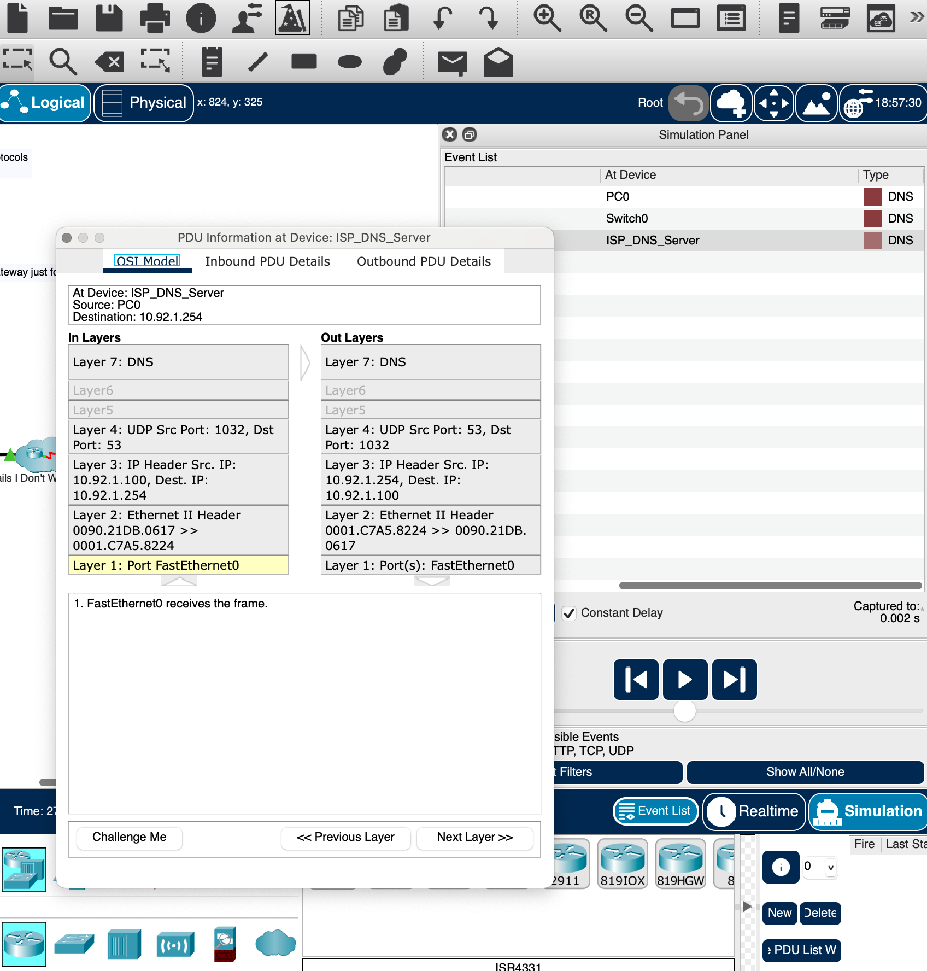

HTTP Packet Opened
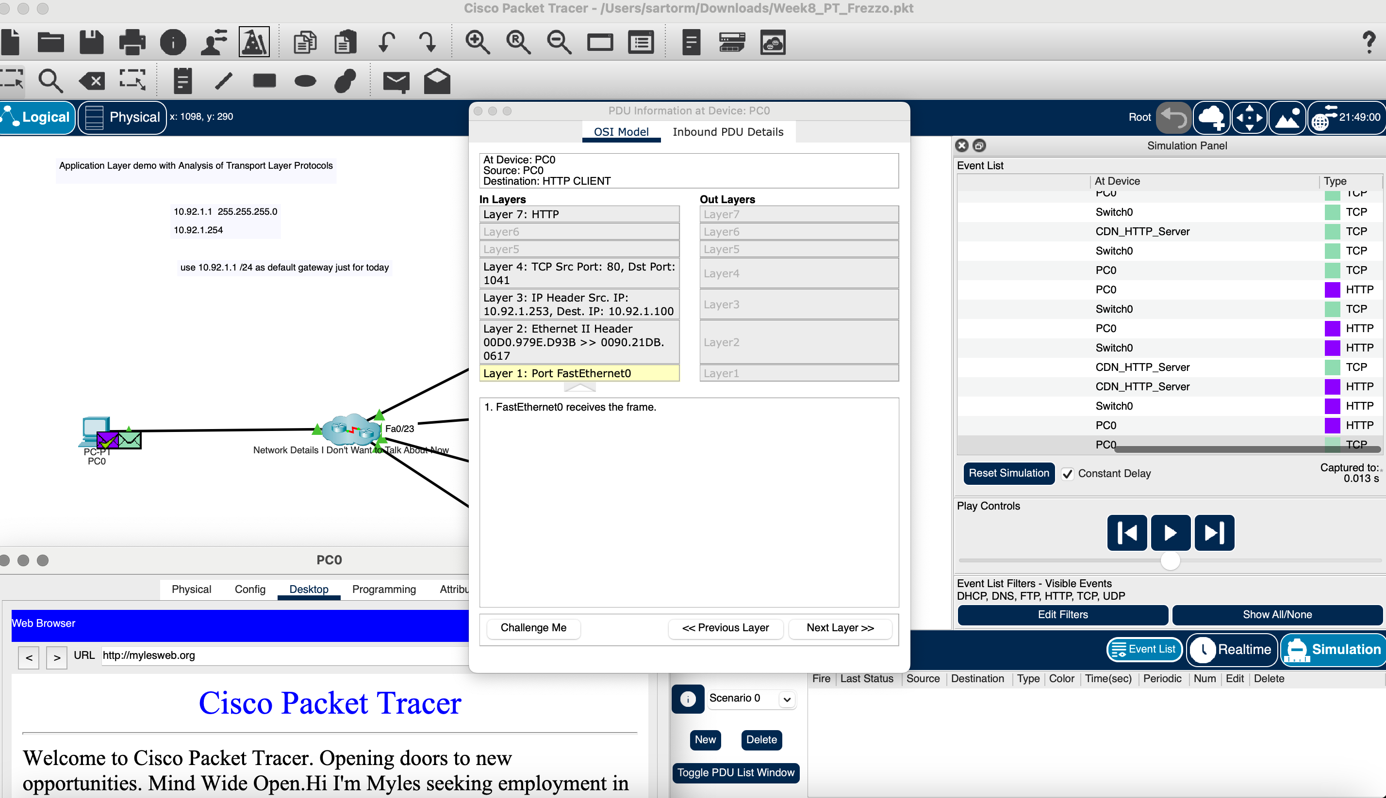

Index 4 Web page with Your Name and the New Color
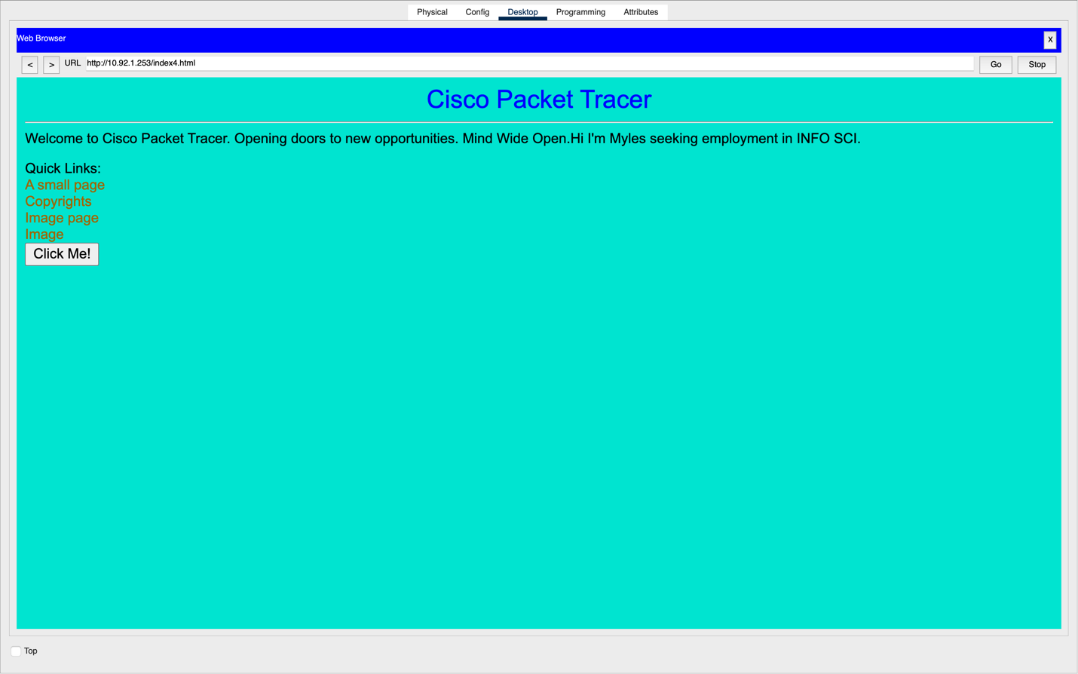

FTP Packet Opened
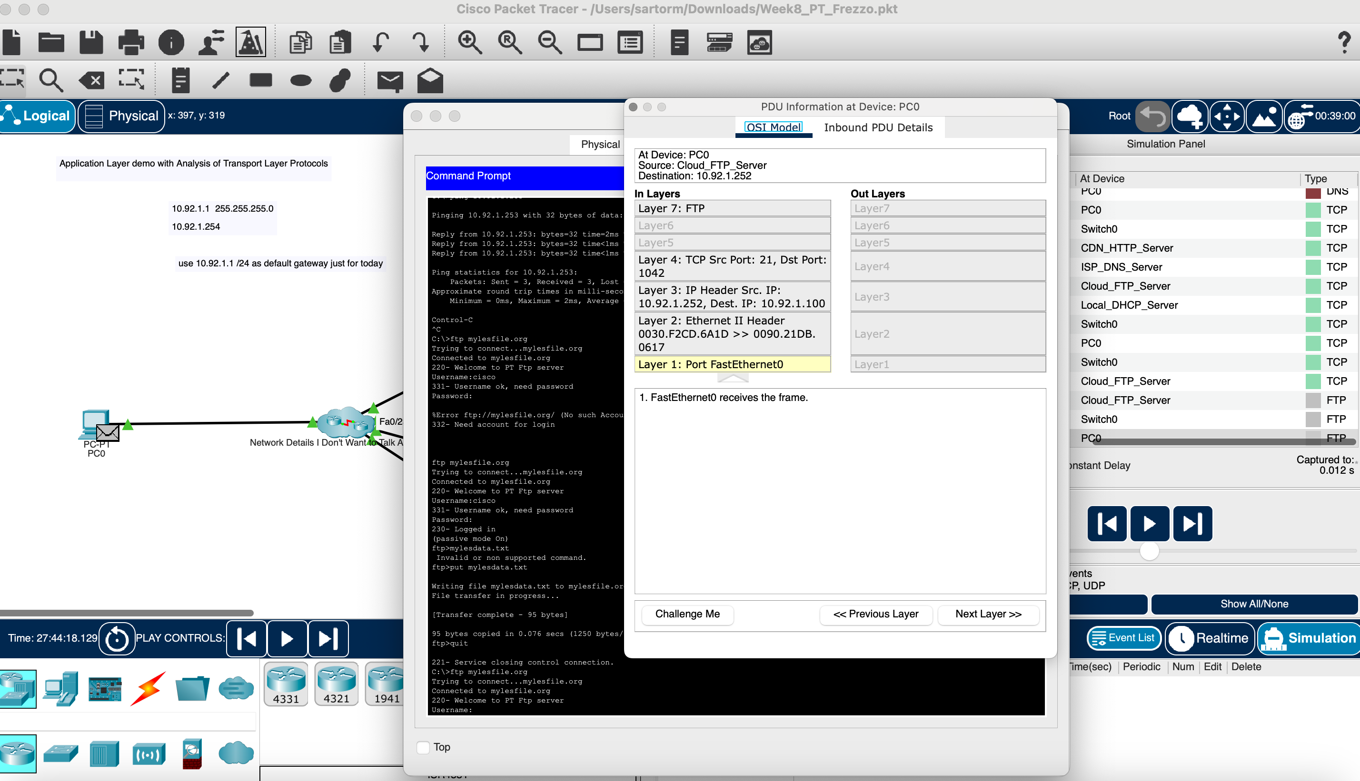

FTP File Transfer Confirmed
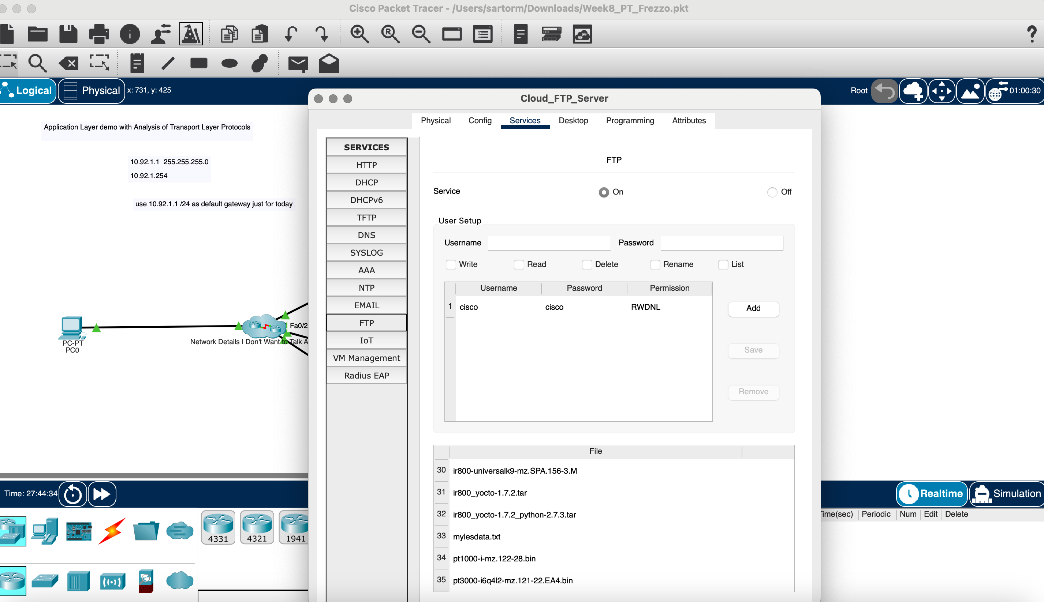

DHCP Packet Opened
